Now we are trying to make the enemy walk or run back in the loop instead of going to the first location of the path.

1. Create an Integer variable in BB called DIrection
2. Depending on this variable BT will decide to walk in forward direction or backward direction.
3. First we will set the direction to forward (or True) in the AIController.
4. 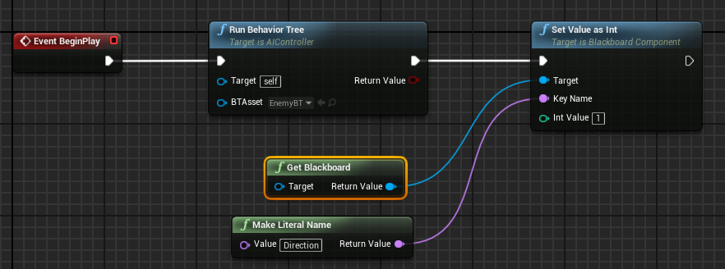
5. This will make sure we move forward in path at the start.
6. Now go to BT and add a selector before the path increment
7. 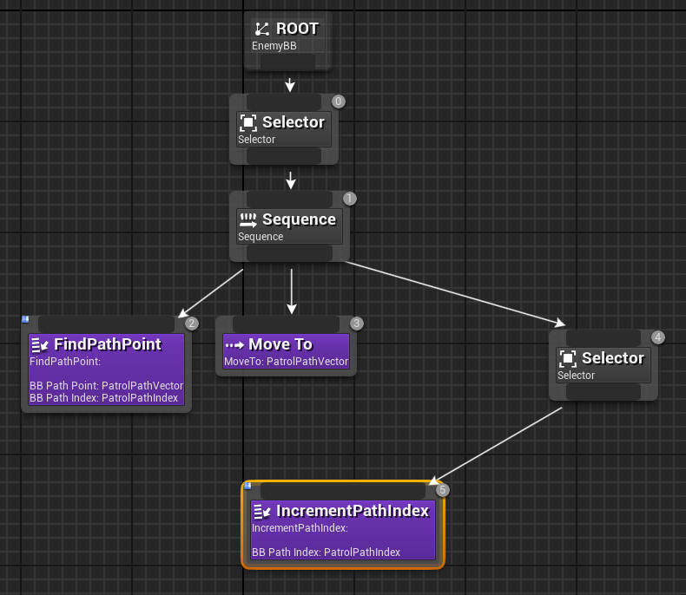
8. Go to the Increment and
9. Add a variable of type BlackBoardKeySelector and name it BB_Direction
10. Check if the direction is forward before doing all the BP
11. 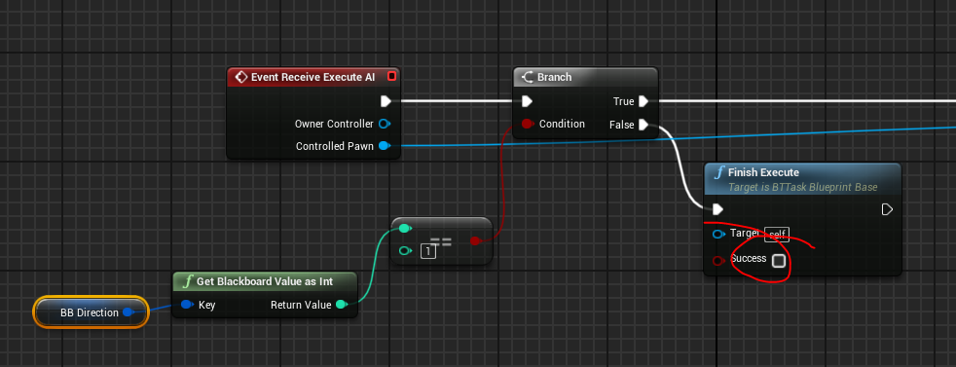
12. Make sure success is set to false so that the if direction is -1 we can execute the decrement path.
13. In the end of the BP if it reaches the end of the path index we need to add some node
14. 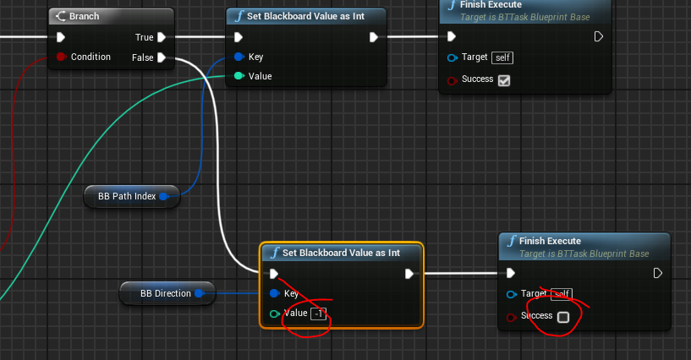
15. The final bp will be as follows
16. 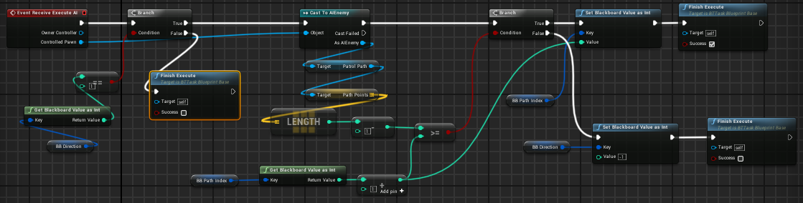
17. We need another task to decrement path.
18. For that we just need to duplicate Increment path and change the script.
19. We can simplify the decrement path BP to as follows
20. 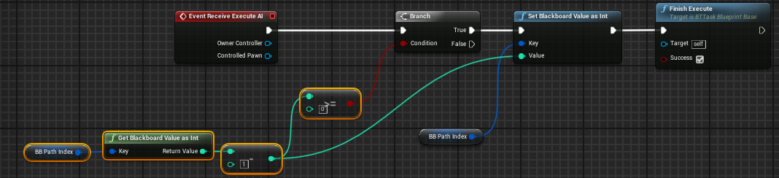
21. We need to do the same checks here.
22. Check if the direction is -1 before the execution
23. 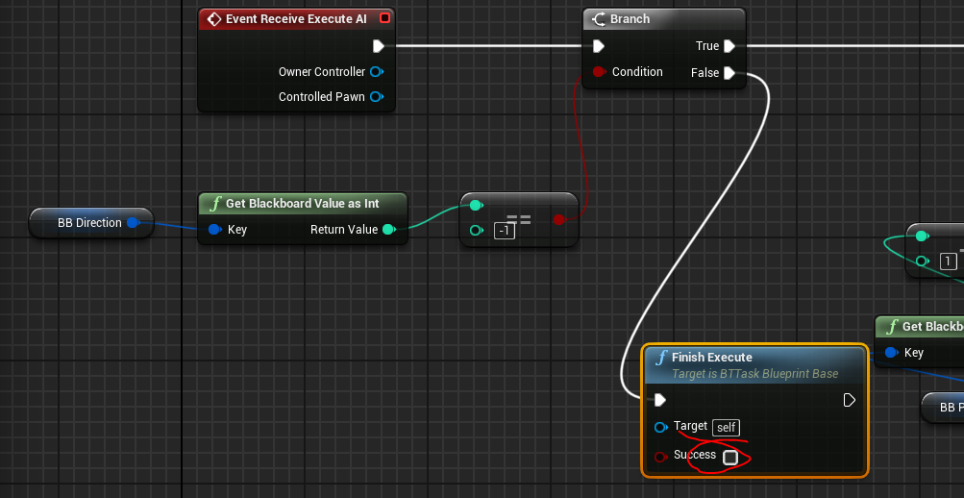
24. When the index reaches 0 then we need to set the direction to 1 and set success false.
25. 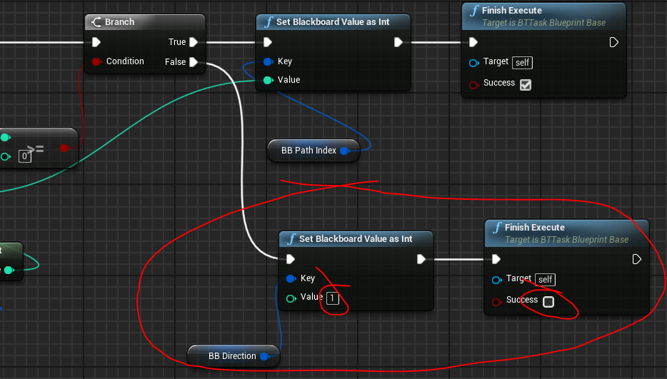
26. The final bp will be as follows.
27. 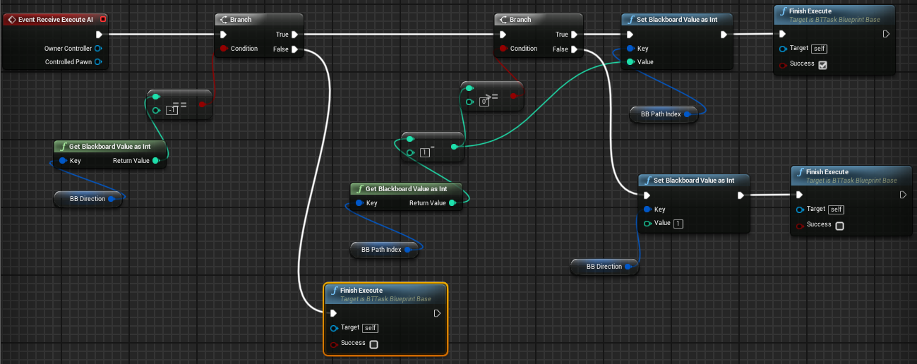
28. Now add those tasks to the BT.
29. Make sure you select appropriate variables in the details.
30. 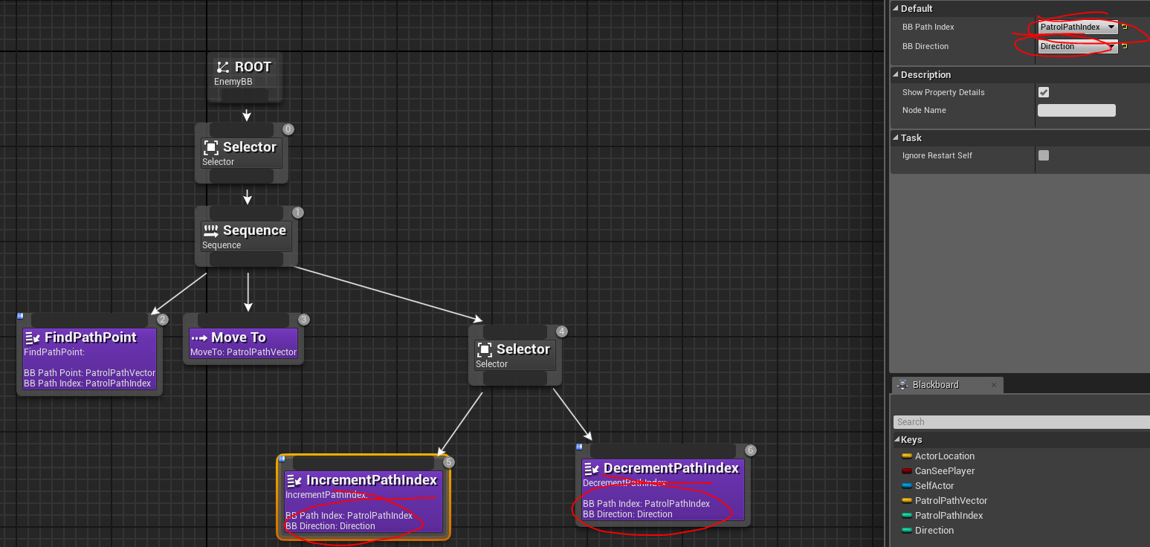
31. We can add a wait before increment or decrement so after reaching each point the character will wail for a while.
32. Now we will try to combine the earlier BT that if the enemy sees the player it will change to chase mode.
33. We will delete the move to random location. Because we will be using the walk on PatrolPath
34. Rename the PatrolPath Sequence to “PatrolPath”
35. Connect the chase player to the selector above the PatrolPath sequence
36. Add a BB based decorator to the PatrolPath sequence.
37. Select the decorator and set BB value to CanSeePlayer and key query to not set.
38. Select the decorator and set observer aborts to Both.
39. Final BT should be like this
40. 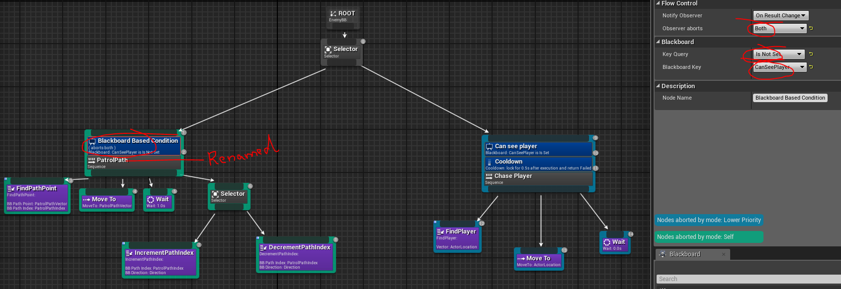
41. Now when you play the Enemy will run on path but when it sees the player it will go to chase mode.
42. Now we want to have different speed for the enemy when in patrol mode and in chase model.
43. For that we need a service. Add a service from the tool box in top.
44. Go to content browser and change the name to ChangeEnemySpeed.
45. In the ChangeEnemySpeed and the following BP
46. 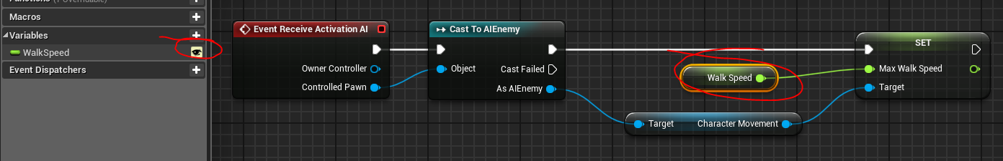
47. Make sure to set the variable Walk speed instance Editable
48. Now add the service to both the Sequences by right clicking on it and adding.
49. Select the service and set the speed to 100 while patrolling and 600 while chasing in the details of the service.
50. 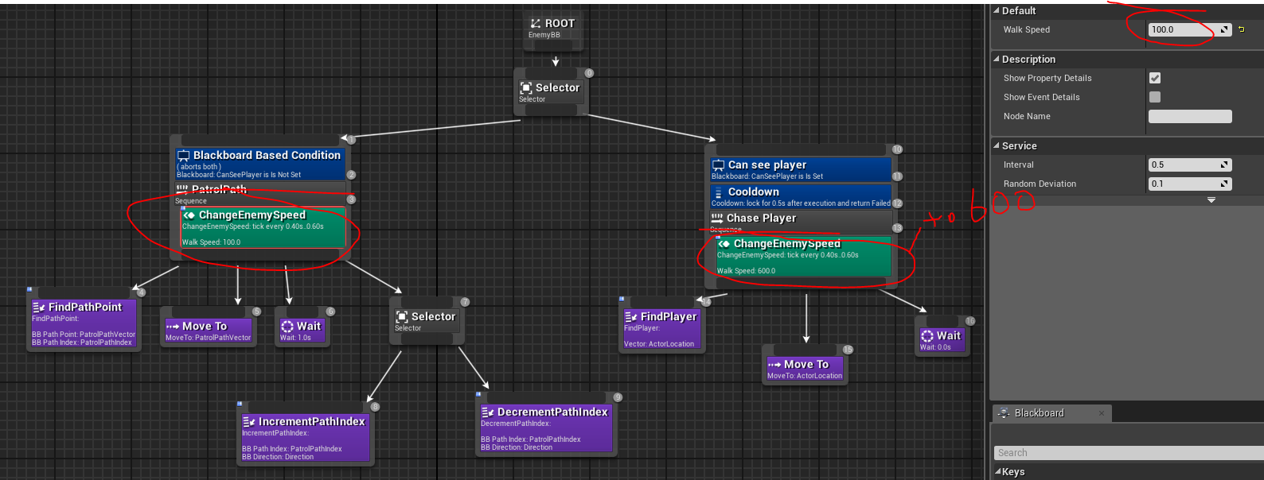
51. We should see the difference in the game.
52. Now the enemy forgets the player as soon as we break the line of sight. We will use enumerators to fix this. We will set the enumerator to chase status patrol status or search status and depending in the enumerator status we will guide the AI character.
53. Go to content browser and add an enumerator.
54. 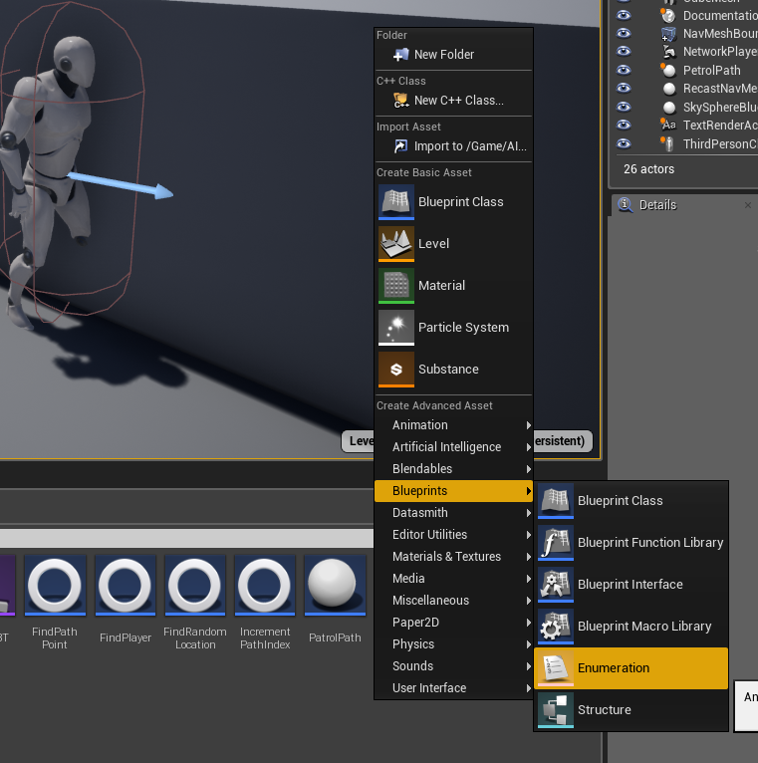
55. Rename it to Chase Status
56. Open it and add 3 values Patrolling, Searching, Chasing.
57. Now we will create a task to change the enumerator status.
58. Go to BT and add a new task.
59. Go to content browser and rename it to ChangeChaseStatus
60. Open it and add 2 variables one Blackboardkeyselector and the other ChaseStatus Enum. Make both of them Instance Editable.
61. Add the following BP
62. 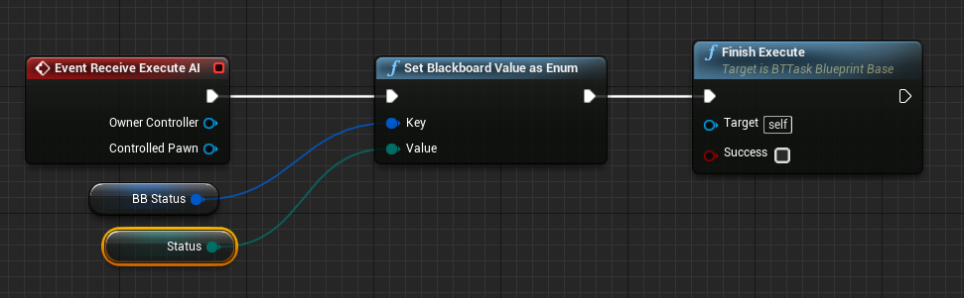
63. Go to BT and add the new task at the end of Chase player sequence.
64. 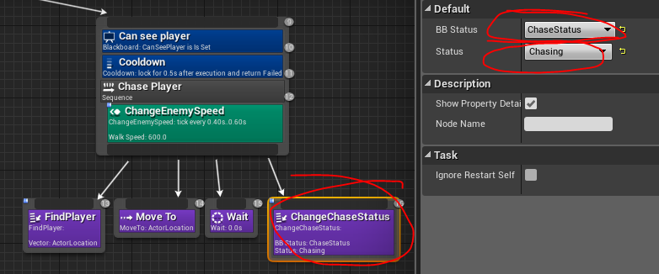
65. Go to BB and add a new key of type enum name it ChaseStatus
66. Select the new task in BT and select appropriate variables in the details panel.
67. Now create a new Selector and connect PatrolPath sequence through it.
68. Add a decorator to the new selector and select the variable can see player and select KeyQuery to “Is Not Set”
69. 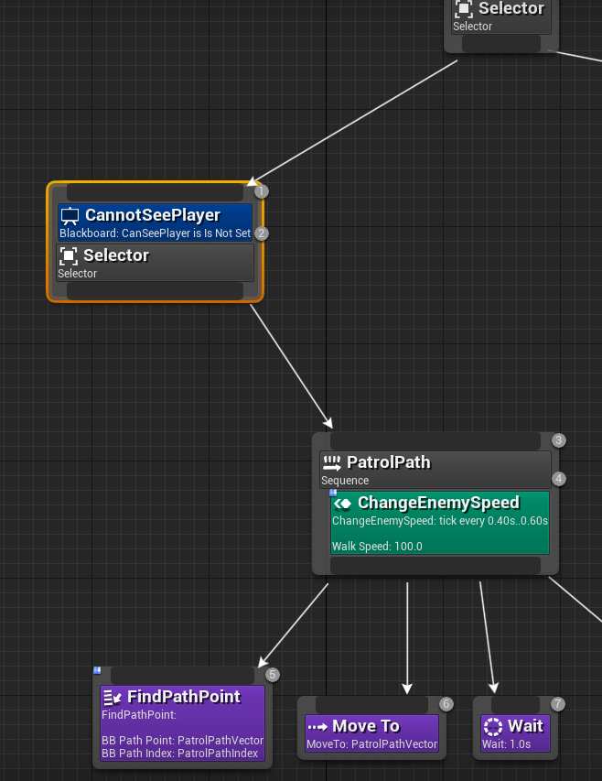
70. Add another new sequence that is branching off from the new selector and add a decorator to it
71. Select the decorator and select the variable ChaseStatus and value Chasing and Key query to “Is Equal To”
72. Rename the decorator to HasBeenChasing
73. 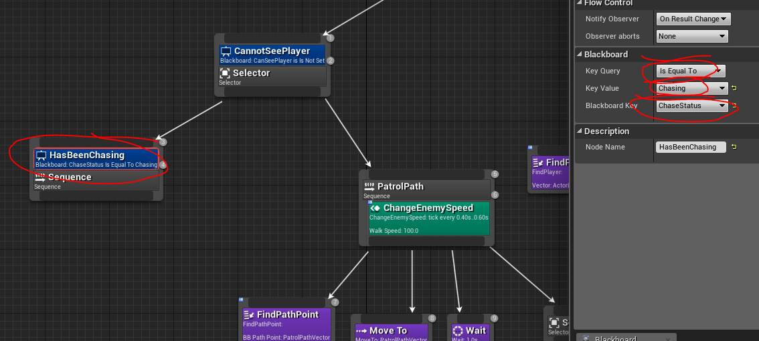
74. Create another sequence and rename it to Searching
75. Open Blackboard and add a vector variable called RandomLoc
76. Connect FindRandomLocation task to new sequence
77. Open it and add a variable of type Blackboard key selector and name it BB_PlayerLoc
78. Edit FindRandomLocation task BP like below
79. 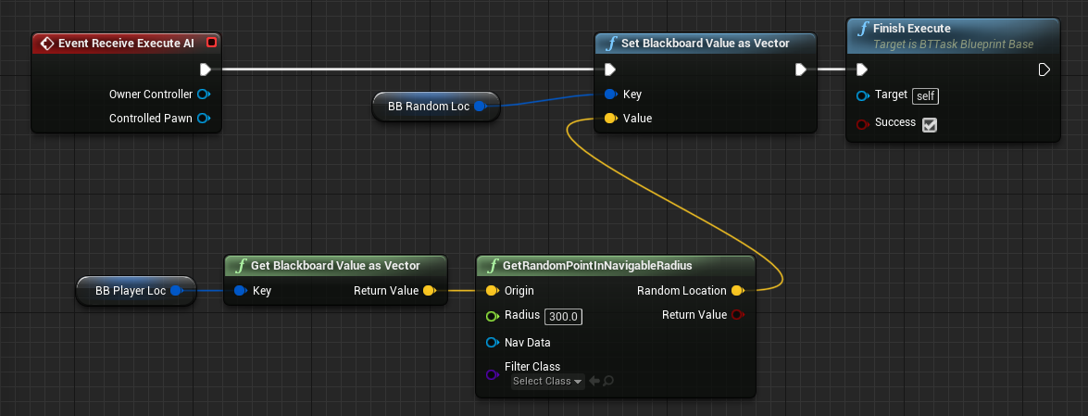
80. Add move to and select RandomLoc variable in details
81. Add a wait node to it as well.
82. Add a decorator Loop to the sequence. (not Blackboard based) This will make the sequence execute in a loop.
83. Select the variables in details panel as shown below for FindRandomLocation task
84. 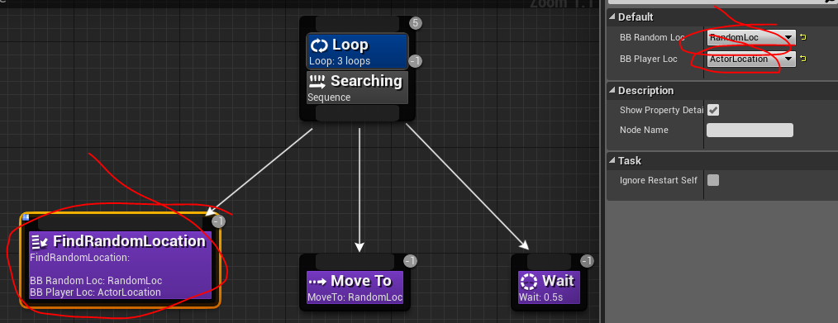
85. Connect the earlier sequence to this sequence and add the task change ‘ChaseStatus’ as another branch.
86. Select the ChangeChaseStatus and select the BB Status to “Chase status” and Status to “Patrolling”
87. 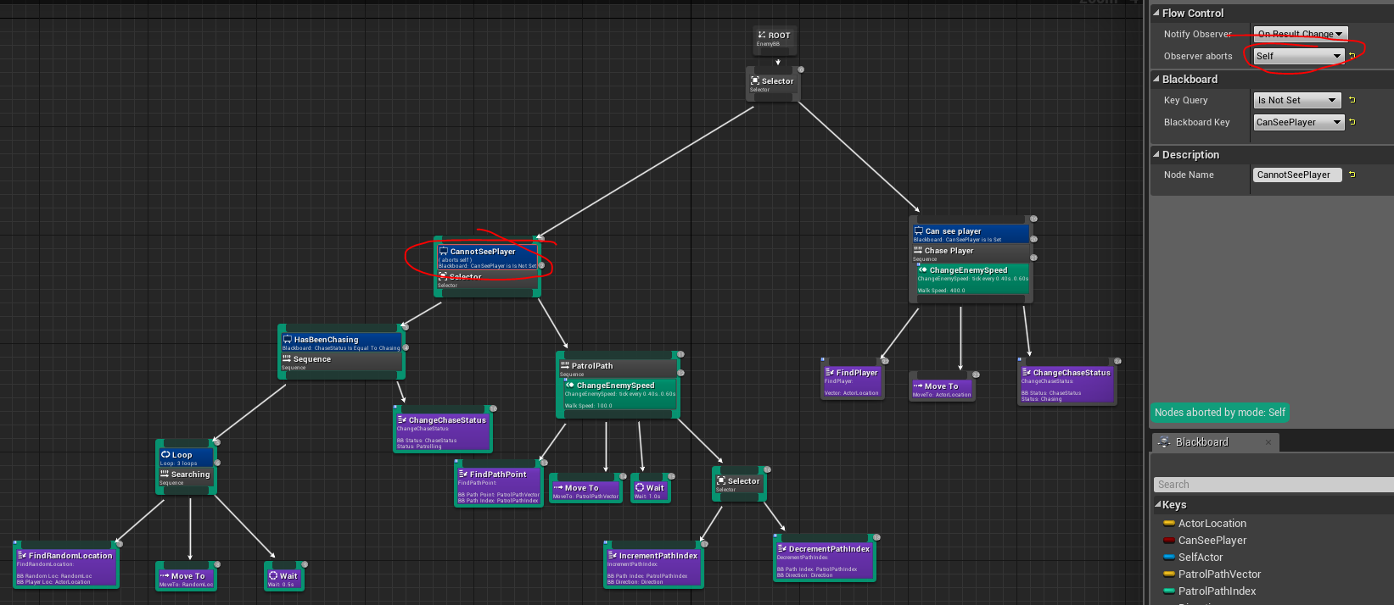
88. Select the Cannot see player decorator and set in details panel obsever abort to ‘Self’